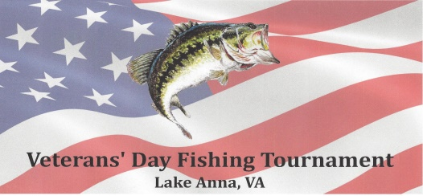
2017 Veterans Day Fishing Tournament
General Information
What: An Open style bass fishing tournament for ALL anglers. Open to everyone. Military Veterans that are active, retired, reserve to receive additional prizes.
Why: To show support for ALL of our Veterans.
Where: Lake Anna, Va. at Anna Point Marina – Fish Tales.
When: Saturday, November 11, 2017 (Veterans Day)….7AM-3PM
Entry Fee: $50 entry fee. ($5 goes toward Big Fish & $5 goes toward donation to Winners Choice of a Veteran Charity.)
Payout: 90% - One place for every 5 boats entered.
Prizes: Over $2500 in prizes awarded to Veterans Guaranteed $500 for 1st place and $250 for Big Fish
Registration: Pre-registration begins on September 11, 2017 – Check or Pay-Pal

Rules
Veterans and supporting anglers may fish as a team (2) or solo w/ no more than 2 per boat
Pre-registration is the PREFERRED & ENCOURAGED method of payment of entry fee. Check must be received by November 6, 2017
……………or PayPal until noon November 10, 2017. CASH ONLY at the ramp the morning of the tournament
VDFT Waiver / Release form must be signed by all anglers
Starting positions are based on the order in which entry fees are received (beginning September 11, 2017)
First flight for boats 1-30 is 7AM…..2nd flight for boats 31-60 is 7:15AM….3rd flight for boats 61-90 is 7:30AM and so on
Weigh in time for boats 1-30 is 3PM…..boats 31-60 is 3:15PM…..boats 61-90 is 3:30PM and so on.
5 fish limit per boat (12” minimum) largemouth or smallmouth bass
At no time can a team have more than six (6) fish in the live well. When a 6th fish is caught, all fishing must stop and culling begin.
All anglers must have valid VA fishing license and abide by all state and federal laws
Only artificial lures may be used…..NO live or dead bait. Scents and pork chunks may be used
Live wells must be in working order and will be checked at blast off at the end of the LONG dock.
No more than one rod / reel per angler at any time and no rods over 8’ in length
No trolling with big motor and no fishing within 25 yards of another angler w/o permission.
No angler may leave the boat to land or catch a fish.
No angler shall leave the boat except in case of emergency, severe storms or nature calls
Life jackets must be worn whenever boat is on plane with kill switch attached
No off limits period and no off limit area unless posted by Dominion Power
All boats must observe the No Wake areas on the lake and use proper safe boating
No culling of dead fish and all live fish to be released at weigh in site. Proper fish handling is expected of everyone.
No alcohol or un-prescribed drugs permitted prior to or during the tournament
Fighting, verbal slander, or any confrontations will not be tolerated & will result in disqualification
All boaters must carry adequate liability insurance and be equipped with USCG safety equipment.
Anglers may put boats on trailers and bring fish to scales in adequate weigh in bags
PLEASE….after weighing your fish and having your picture taken….release fish immediately at the end of one of the floating docks
PLEASE….use proper ramp etiquette…..unload and load quickly and DO NOT BLOCK RAMP

Penalties
Anglers will be penalized 4 ounces (.25 lb) for each dead fish which includes Big Fish
Any team weighing a fish under 12” will be penalized 1 lb per fish under 12”
Teams will be penalized 1 lb per each minute they are late to weigh in time
Teams more than 10 minutes late will be disqualified
In case of a breakdown, you may travel back to the weigh in with your fish in another boat

