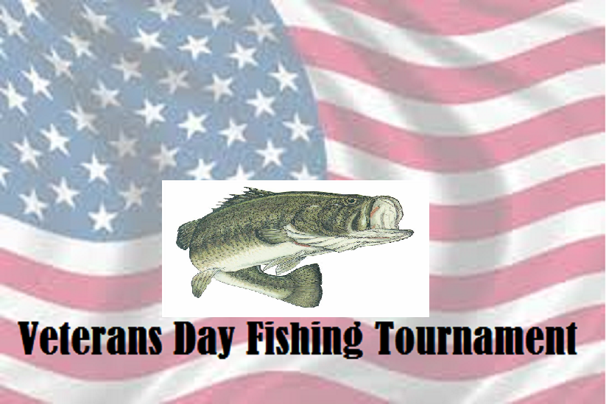
^{5th Annual}

Lake Anna, Va. Anna Point Marina
Saturday - November 11, 2017
Come celebrate & compete on Veterans Day with
Veterans & Their Supporters.
Open to one and All. Registered Veterans, Retired, Reserve, or Active Military will be awarded additional prizes
Contact Larry Martin for more info
e-mail: vdft.lka@gmail.com or 540-222-5420

